A New Way Forward
DOAS Flexible Benefits Premium Tool
Training Participant Guide
March 2023

Slide 1

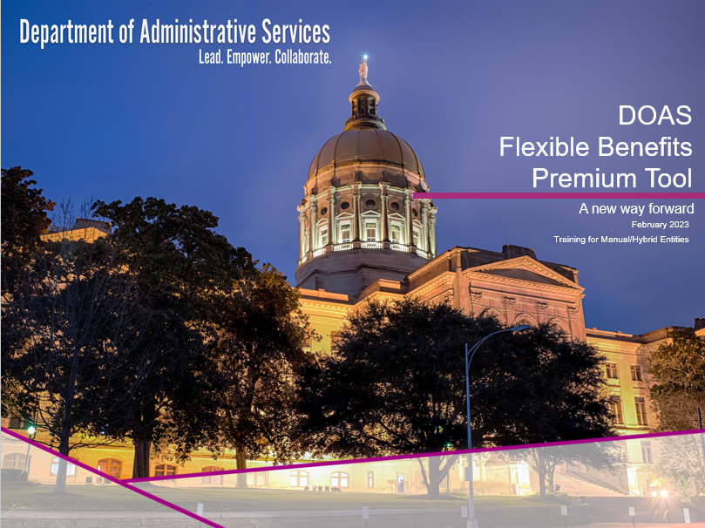

Slide 2

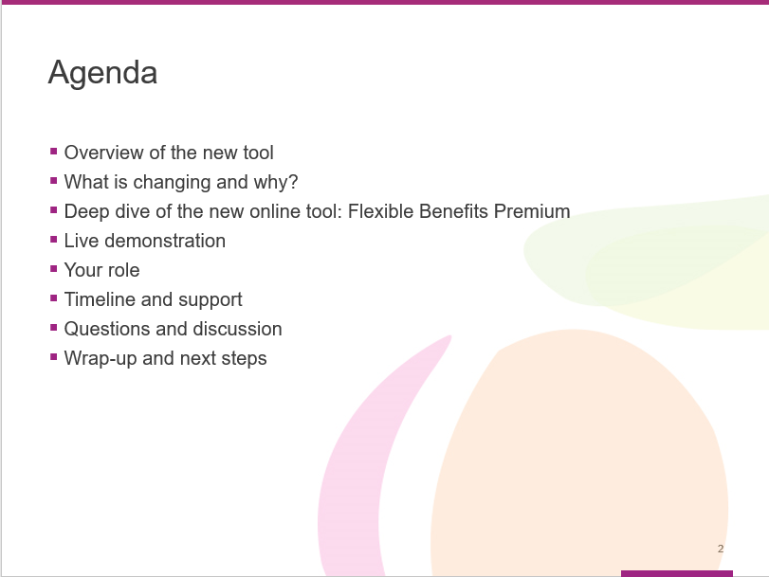

This training will cover the following topics:

- Overview of the new tool
- What is changing and why?
  - Deep dive of the new online tool: Flexible Benefits Premium
- Live demonstration
- Your role
- Timeline and support
- Questions and discussion
- Wrap-up and next steps

Slide 3

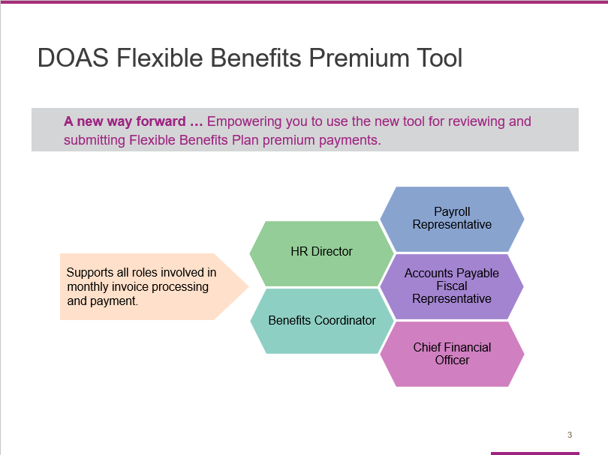

During this session, our goal is to equip and empower you to start using the new payment tool for reviewing and submitting Flexible Benefits Plan premium payments.

Notice the tag line – “A new way forward.” We selected it because this new tool is designed to simplify your workload and make the payment process faster and easier.

This training is designed to support all roles involved in monthly invoice processing and payment, including:
- HR Director
- Benefits Coordinator
- Payroll Representative
- Accounts Payable Fiscal Representative, and
- Chief Financial Officer

Slide 4

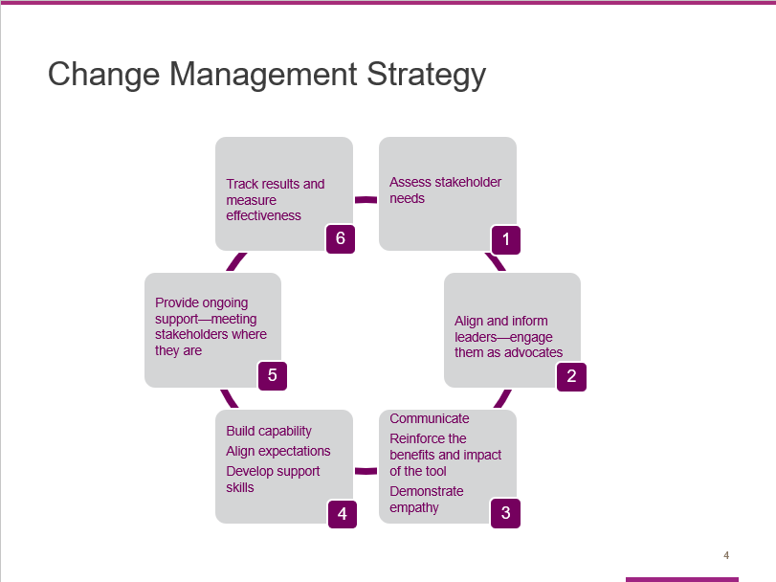

The change management strategy we developed to help you adopt the new Flexible Benefit Premium tool has six phases:

- We started by assessing the needs of our participating entities, who will be the primary stakeholders in this effort.
- We also focused on aligning and informing key leaders so they are comfortable serving as advocates for the new tool.
- The third and fourth phases of our change management strategy are closely related.
- Phase 3 centers around our commitment to communicating clearly – so entities can learn the benefits and expected impact of the new tool. At the same time, we want to demonstrate empathy. Change can be hard, even when it is for the better.
- Phase 4 focuses on building capability by helping impacted entities get comfortable using the new tool, making sure they understand what is expected and helping them develop the necessary skills. Today’s training is a key component of Phase 4.

- Effective change management also requires that we provide impacted entities with ongoing support – by meeting them where they are in the learning/adoption process.
- The final component of our change management strategy is to track results and measure the effectiveness of our efforts.

Slide 5

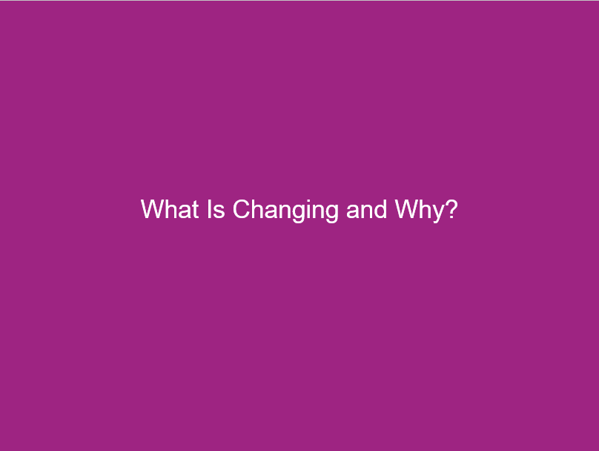

During this section, we will quickly recap what’s changing and why.

Slide 6

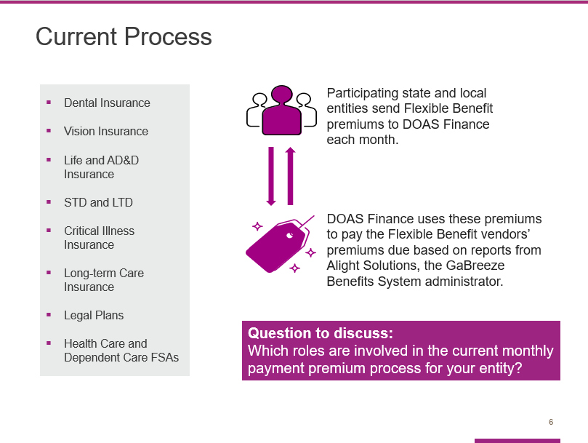

As you know, the Georgia Department of Administrative Services (DOAS), Human Resources Administration (HRA) division is dedicated to providing HR and talent management solutions that empower state entity HR and business leaders to manage their workforce in an effective and efficient manner.

One of the most critical services we provide is the administration of the State of Georgia Flexible Benefits Program, including:
- Dental Insurance,
- Vision Insurance,
- Life and AD&D Insurance,
- STD and LTD (Short-Term Disability and Long-Term Disability),
- Critical Illness Insurance,
- Long Term Care Insurance,
- Legal Plans, and
- Flexible Spending Accounts for Health Care and Dependent Care.

The visual on the left of the slide illustrates how the monthly process works now. As you can see, participating state entities send Flexible Benefit premiums to DOAS Finance each month. DOAS Finance uses these premiums to pay the Flexible Benefit vendors’ premiums due based on reports from Alight Solutions, the GaBreeze Benefits System administrator. ​

Because this process is complex and time-consuming, DOAS and Alight have partnered to improve the process through a more streamlined and efficient online tool.

Question to consider: Which roles are involved in the current monthly payment premium process for your entity?
Slide 7

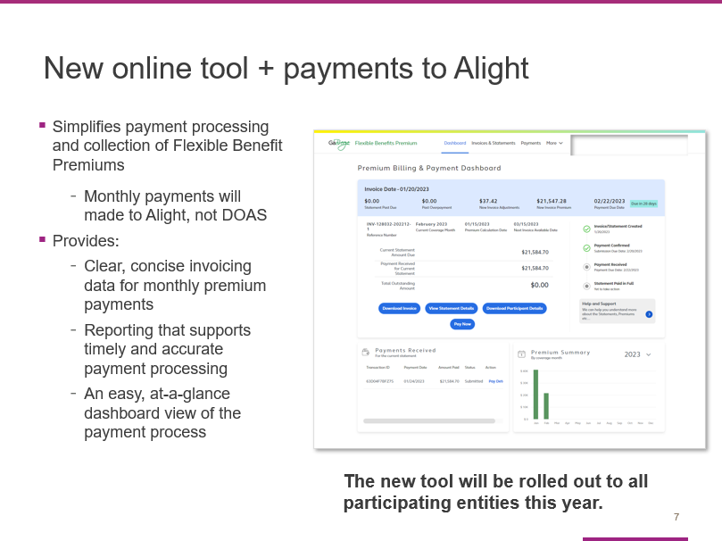

To address these challenges and simplify your work effort, we have partnered with the GaBreeze Benefits System administrator, Alight Solutions, to develop a new online tool that will replace this process.

This tool will provide us with a system that provides clear, concise invoicing data for premium payments, as well as reporting that supports timely and accurate payment processing.

It was developed specifically for DOAS and you, our participating entities.

More importantly, it is designed to simplify payment processing and collection – providing you with easy, online access to clear and concise statements, invoices and reports.

And here’s the best news: The new tool is rolling out to all participating entities now, you can start using the tool for upcoming invoices.

Slide 8

In this section, we will take a closer look at the new tool.

We will start by reviewing the key features using screen shots and then do a live demo.

Slide 9

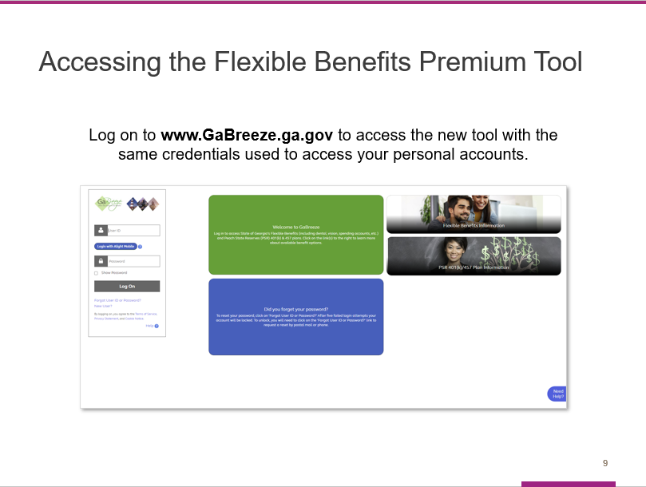

Going forward, you will use the Flexible Benefits Premium tool to view your remaining outstanding premium amount and to make applicable payments.

All users will access the new online tool through the UPoint GaBreeze site at www.GaBreeze.ga.gov (under the Administrative Tools section).

You will need your User ID and password to authenticate into the site.

If you do not remember your credentials, select the Forgot User ID or Password link under the Log On button. Then follow the prompts to reset your credentials. If you need to reset your credentials if you have a cell phone number online, you can receive a one-time code to update your password. Otherwise, your password will be sent you via the US Postal Service.

If you are new to the site, select the New User link, also under the Log On button, and then follow the prompts to set up your credentials.

Finally, please note that the User ID and password are the identification credentials used to access their personal accounts and not the User ID used to access the normal GaBreeze Employer Portal.

Slide 10

Once you are logged into the GaBreeze site you can access the Flexible Benefits Premium tool via the top drop-down menu.

Entity users who have been granted access to the tool will see an Administrative Tools drop down on the far left at top of the page.

Selecting this drop-down will route the entity user to a page which will link out directly to the Flexible Benefits Premium tool.

Slide 11

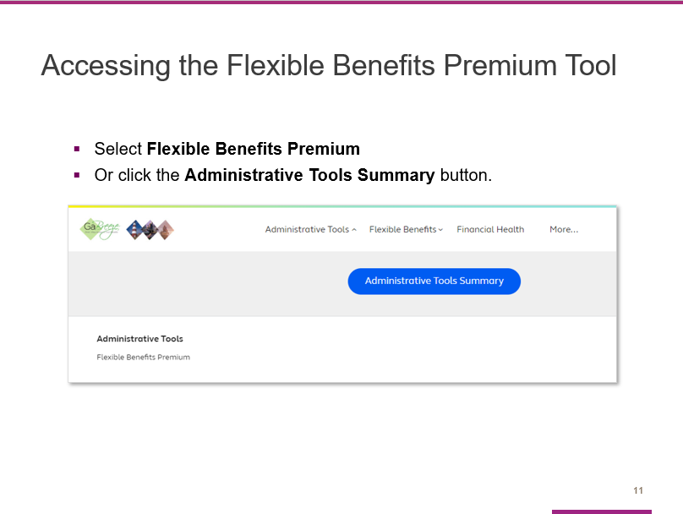

After you select the Administrative Tools drop-down, you will see this page. The words Flexible Benefits Premium are a direct link out to the tool.

In addition, a new Administrative Tools Summary button appears. This is where Alight will be storing access to multiple tools, including the Flexible Benefits Premium.

Clicking on this button will take you to the Tools Summary page.

Slide 12

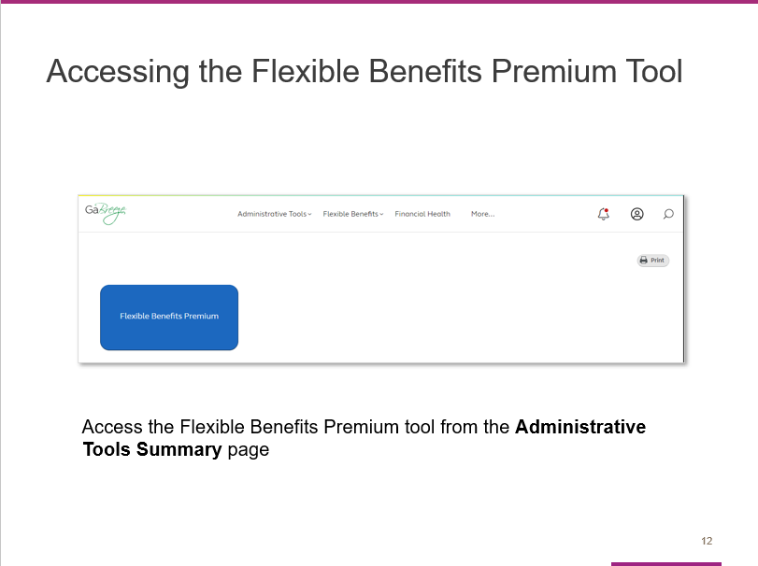

The Flexible Benefits Premium tile can also be clicked on this page and will route the entity user directly into the Flexible Benefits Premium tool.

Slide 13

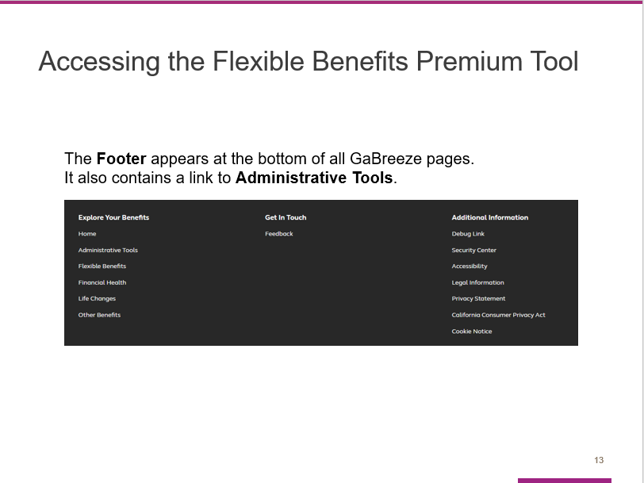

GaBreeze web site pages also include Footers at the bottom of each page. The footer contains a link to the Administrative Tools as well.

Slide 14

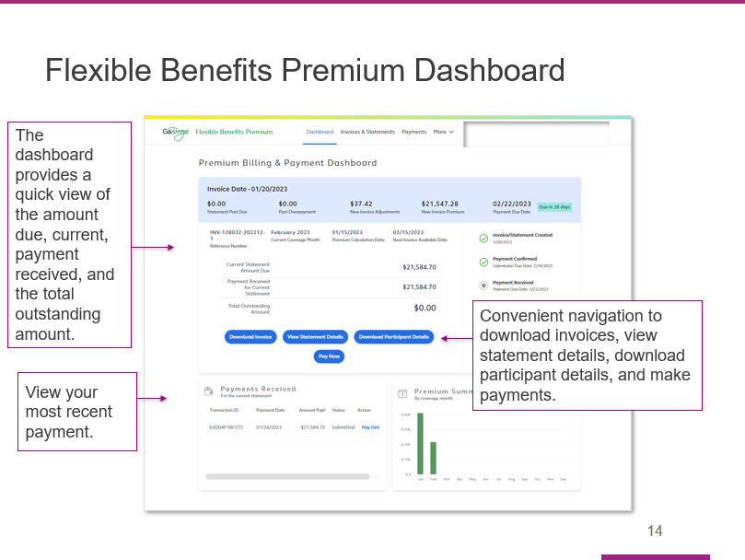

This dashboard is the first screen you will see after you access the new tool.

It provides an easy, at-a-glance view of the payment process.

The light blue bar at the top shows the invoice date as well what makes up the current amount due, specifically:
- The new invoice premium,
- The new invoice adjustments, and
- Any past due amounts.

This section of the dashboard also shows the invoice/statement date and the payment due date.

The section under the blue bar shows the current statement amount due, the payment received for the current statement, and the total outstanding amount.

You can use the dark blue buttons to download the invoice, view statement details, download participant details, or pay.

The Payments Received section allows you to view your most recent payment.

Slide 15

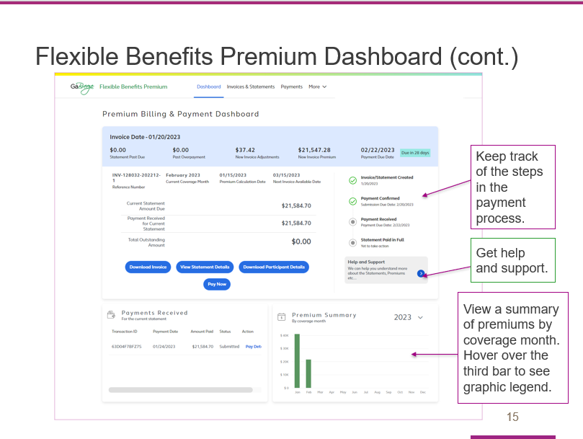

On the right side of the dashboard, you will see a tracker that helps you keep track of where you are at in the payment process.

You will also find a help and support button that connects you to additional resources.

The bottom section of the dashboard allows you to view payments received as well as a premium summary. Hover over the third bar to see the graphic legend.

Slide 16

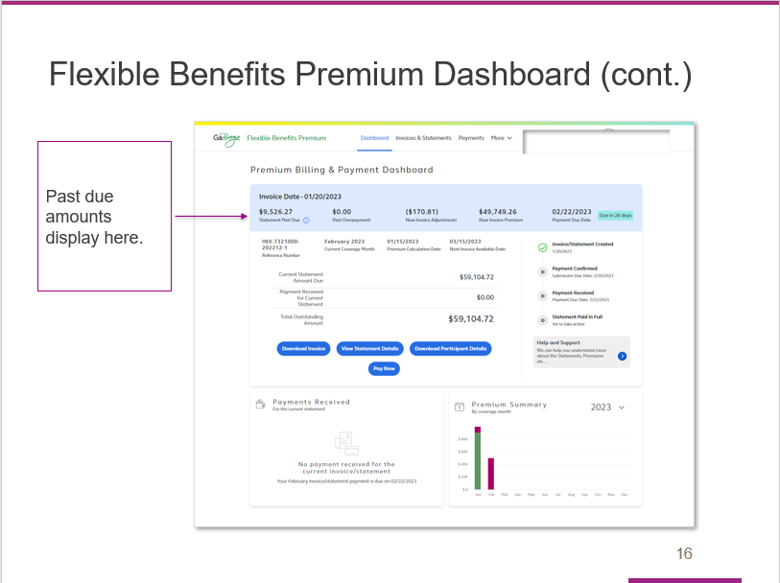

The tool allows you to easily view past due amounts from the Invoice Date section at the top of the page.

Slide 17

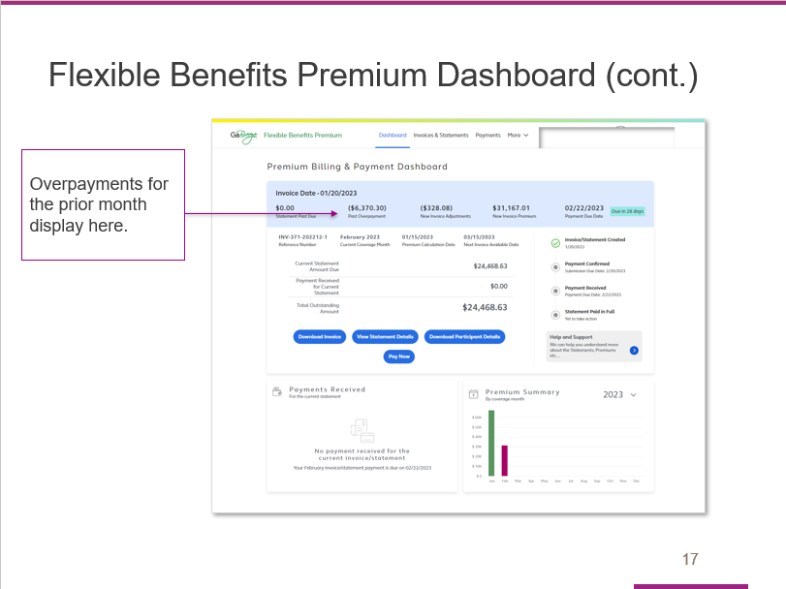

The Invoice Date section also shows any overpayments for the prior month.

Slide 18

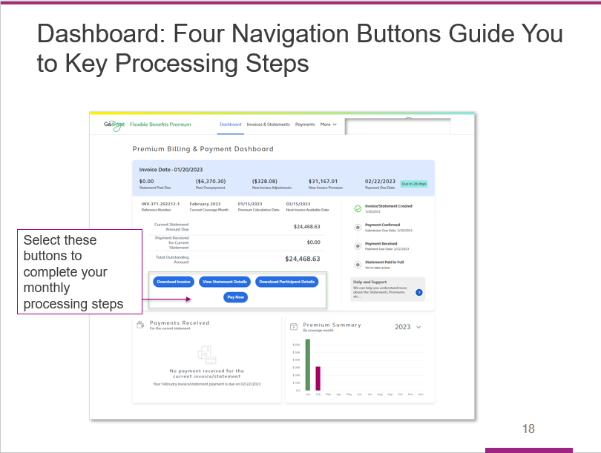

The four blue navigation buttons are another important feature of the dashboard.

These buttons are designed to guide you through the four key invoice processing steps each month:

- Downloading the invoice

- Viewing statement details

- Downloading a file with participant details, and

- Paying the invoice.

Slide 19

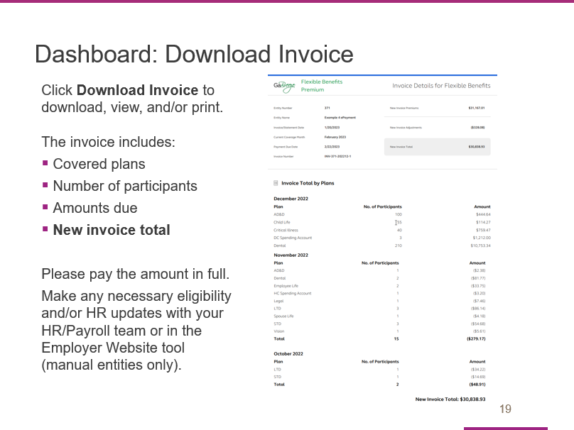

When you select the Download Invoice button from the dashboard, the tool will open your most recent invoice.

It is important to check the invoice to confirm the following information for each month:

- Covered plans,

- Number of participants, and

- Amounts due.

The new invoice total is shown at the bottom of the invoice.

Please pay the amount in full.

If any eligibility and/or HR updates are needed, please make them with your HR/Payroll team. Note that manual entities will use the Employer Website tool.

Slide 20

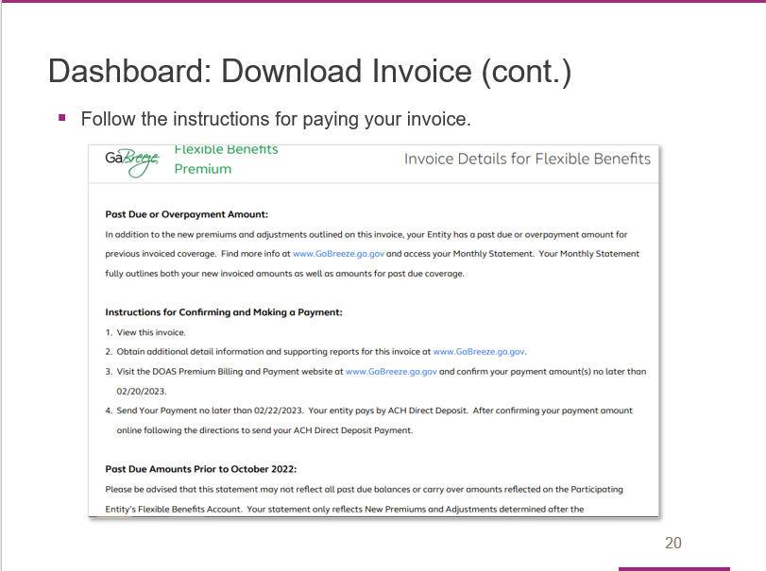

Be sure to follow the instructions provided when you pay your invoice.

Slide 21

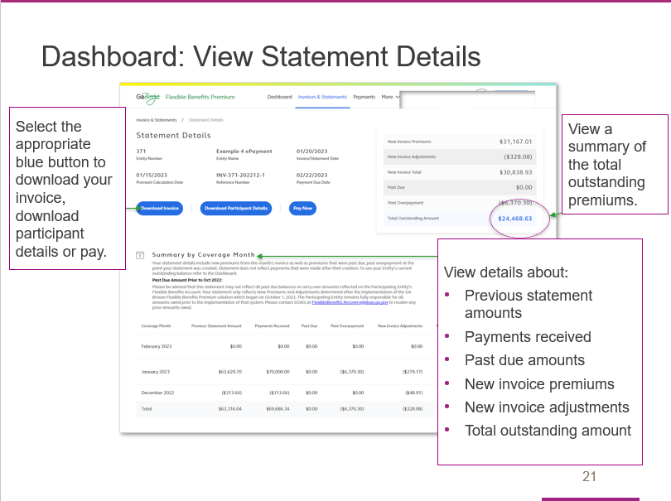

When you select the View Statement Details button, you will link to the Statement Details page that is shown here.

You can use the three blue navigation buttons to download your invoice, download a file with participant details or pay.

This page also provides a summary of the total outstanding premiums, as well as a Summary by Coverage Month section with details about:
- Previous statement amounts,
- Payments received,
- Past due amounts,
- New invoice premiums and new invoice adjustments, and
- The total outstanding amount.

Slide 22

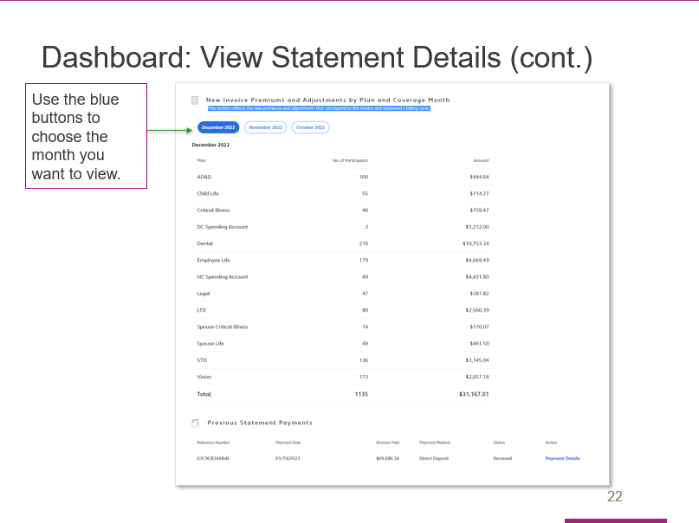

Here is a screen shot of the additional information you’ll see as you scroll through the statement screen.

Use the blue buttons to choose the month you want to view.

Slide 23

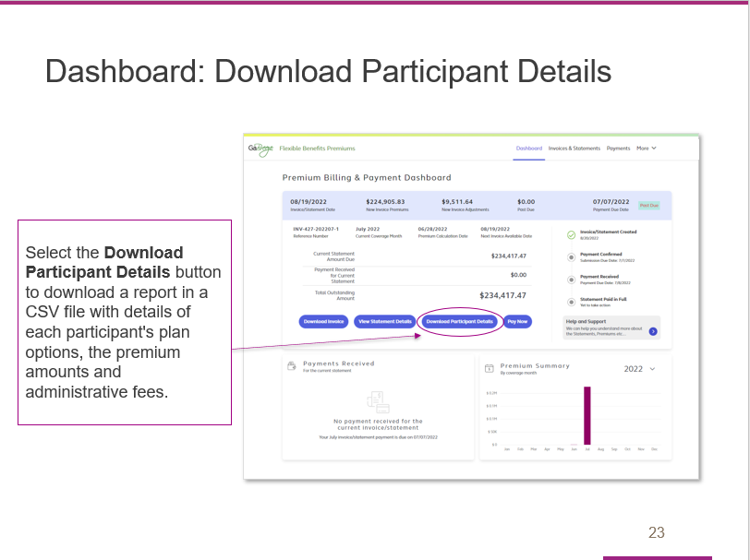

After you select the Download participant details button, the tool will download a report in a CVS file with details of each participant’s plan options, the premium amounts and administrative fees.

Review this file to confirm the number of participants covered since that is what determines the premium amounts due.

Slide 24

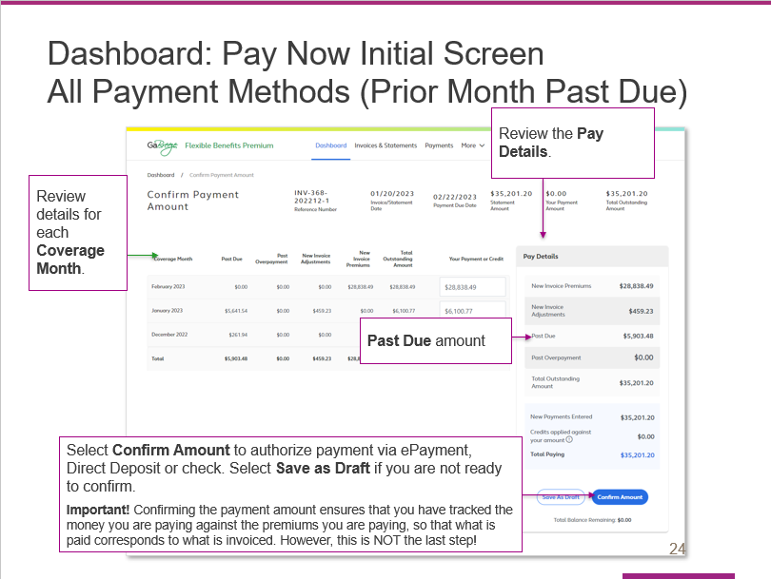
Here is the screen that appears when you select the Pay now button from the dashboard. This initial screen is the same whether your entity pays by ePayment, Direct Deposit or Check – with one exception that I’ll cover at the end.

Start by reviewing the details for each Coverage Month.
- Coverage Months correspond to the actual coverage of your employees. However, Coverage Months premiums are not always calculated in the actual month of coverage. This is because retroactive enrollments (such as a birth of a child enrolled in coverage after birth) can adjust previous months coverage.
- Therefore, in each invoice you will likely see nearly all of your premiums in the current Coverage Month, but you may also see adjustments to previous Coverage Months.
- Adjustments can be both positive (additional money due) or negative (credits against other premiums due).

The next step is to review the pay details for the current amount due. [Presenter to highlight each item on the list.]

When you have completed that step, hit Confirm Amount to authorize your payment via ePayment, ACH or check (depending on your agency). This confirmation step ensures that you have tracked the money you are paying against the premiums you owe, so that what is paid corresponds to what is billed. However, please note that this is not the last step in the confirmation process. It simply takes you to the NEXT steps in the payment/confirmation process.

If you are not ready to confirm and pay, you can select Save as draft before you leave the page.

This screen is the same for all 3 payment methods I just mentioned. However, the next steps and screens differ by payment method. As a result, there is a different message at the bottom of this screen with specific information about next steps for each payment method.

Final note before we move on: This example shows a Past Due amount from the prior month of $4,903.48. This Past Due amount is ADDED to the Total Outstanding Amount on this screen.
Slide 25

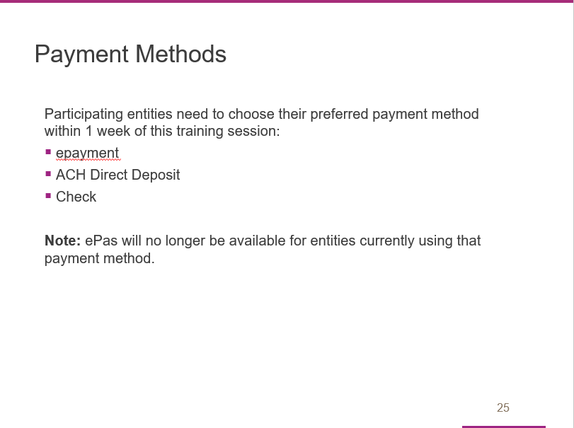

Participating entities need to choose one of these forms of payment within 1 week of this training session:
- epayment
- Direct Deposit
- Check

If your entity is currently using ePas, that payment method will no longer be offered. Your entity will need to choose one of the above payment methods.

We’ll cover the payment steps for each form of payment next.

Slide 26

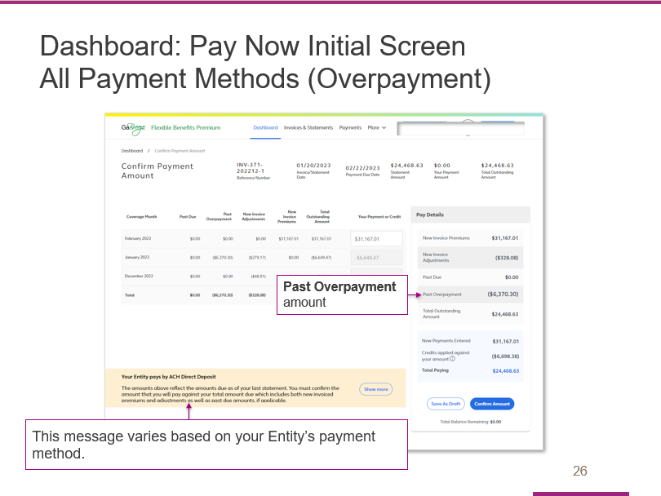

This screen shot is identical to the one we just viewed with one exception:

Instead of showing a Past Due amount for the prior month, it shows a Past Overpayment amount.

As you can see, the Past Overpayment is SUBTRACTED from the Total Outstanding Amount.

Note: The message in the tan box at the bottom of the screen varies by payment method. This example shows the message for Entities that pay by ACH Direct Deposit. If your Entity uses a different payment method, you will see a different message.

Slide 27

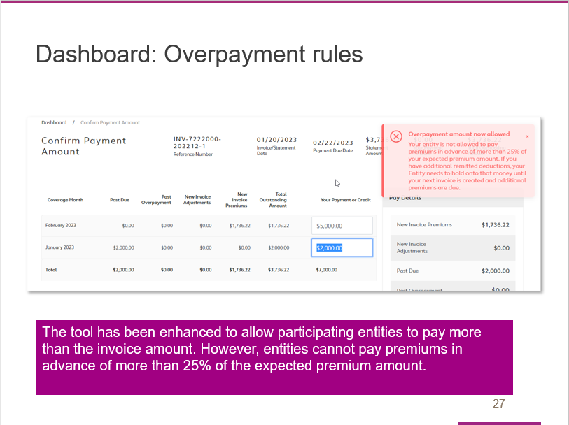

All entities can make overpayments if they so desire.

However, there is a limitation on how much they can overpay.

That limit is no more than 25% of total outstanding balance for the current cycle.

An entity that attempts to pay more than the limit will see the Overpayment Edit shown on this screen shot.

Slide 28

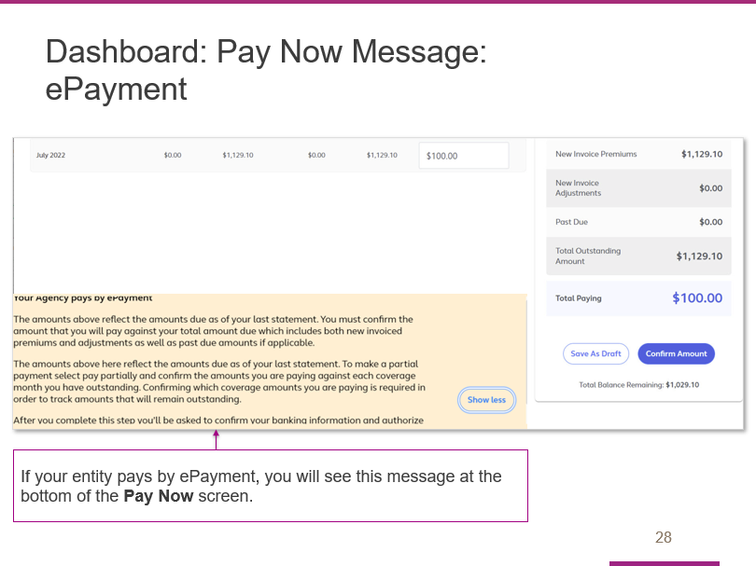

If you are paying by ePayment, you will see this message at the bottom of the Pay Now Screen. Please review before you select Confirm Amount.

Slide 29

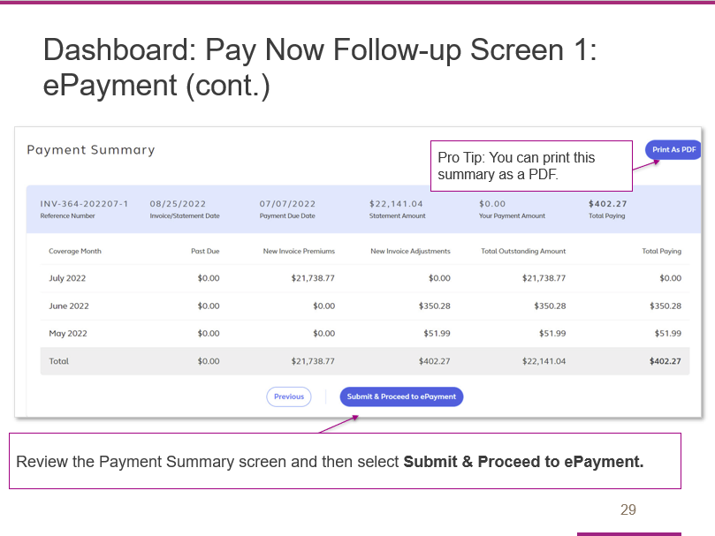

You will see this Payment Summary Screen after you select Pay Now.

Review the summary for each month and select Submit & Proceed to ePayment.

For entities that are paying via ePayment, the authorization to formally submit the payment will be limited to the AP Fiscal Representative and Chief Financial Officer at the entity.

Slide 30

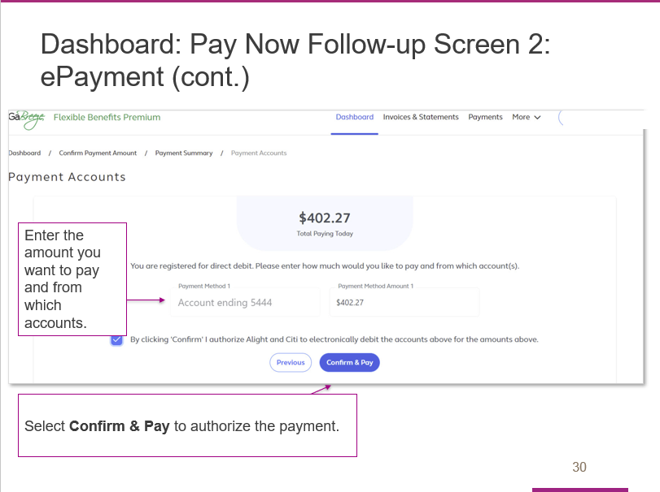

Here is the screen that appears after Submit & Proceed to ePayment is selected.

The AP Fiscal Representative or Chief Financial Officer will need enter the amount they want to pay and indicate the bank account the payment should be taken from.

Their final step is to select Confirm & Pay to authorize payment.

Slide 31

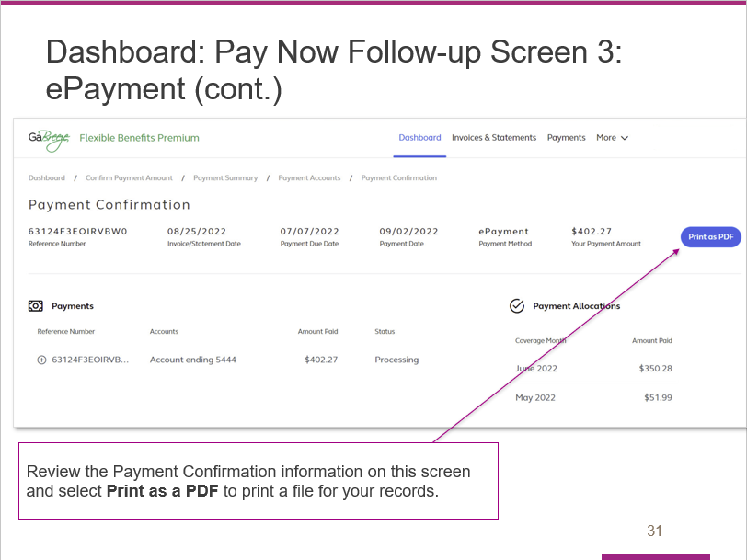

This Payment Confirmation screen will appear after the ePayment is authorized.

The entity’s AP Fiscal Representative or Chief Financial Officer should review and then select Print as a PDF to obtain a copy for your entity’s records.

Slide 32

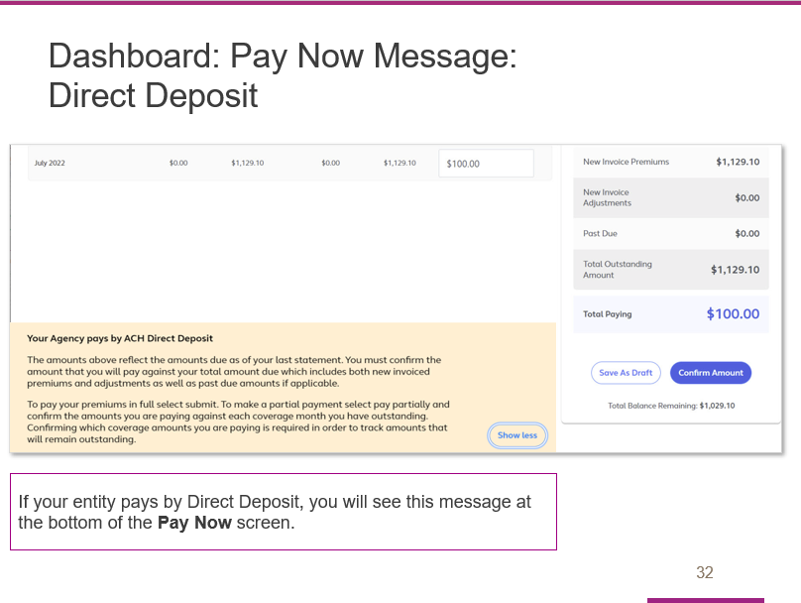

If you are paying by Direct Deposit, you will see this message at the bottom of the Pay Now Screen. Please review before you select Confirm Amount.

Slide 33

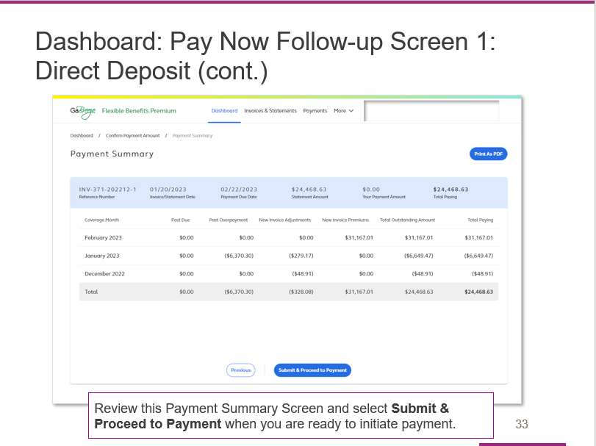

Here is the Payment Summary Screen that appears for entities that pay by Direct Deposit.

Review the summary and then select Submit & Proceed to Payment to begin the payment process.

Slide 34

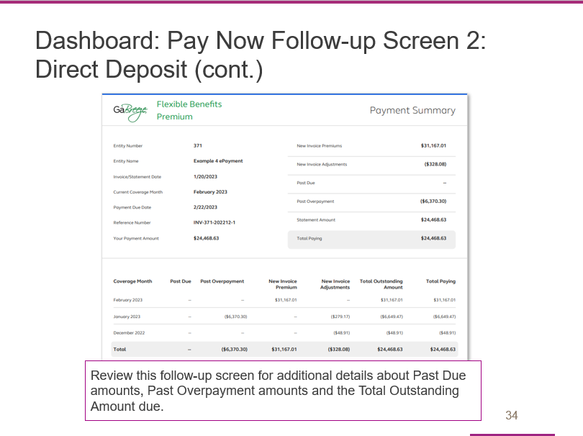

After you begin the payment process, you will see this screen, which contains details about any Past Due amounts, Past Overpayment amounts and your Total Outstanding Amount due.

Slide 35

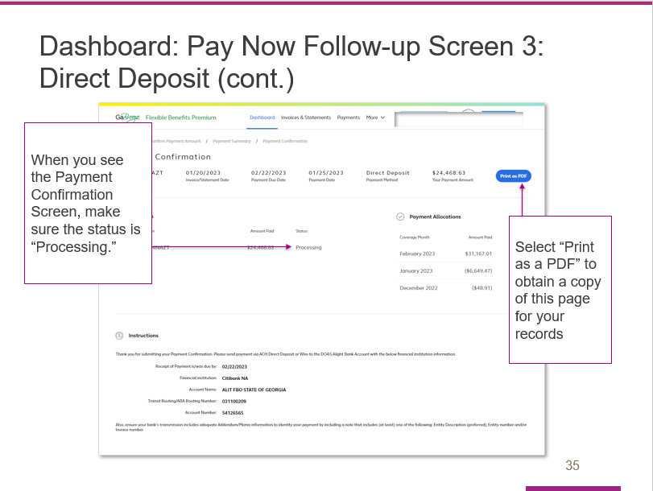

After you begin the payment process, you will see this Payment Confirmation Screen.

Check to make sure the status is Processing.

Select Print as PDF to obtain a copy of this page for your records.

Slide 36

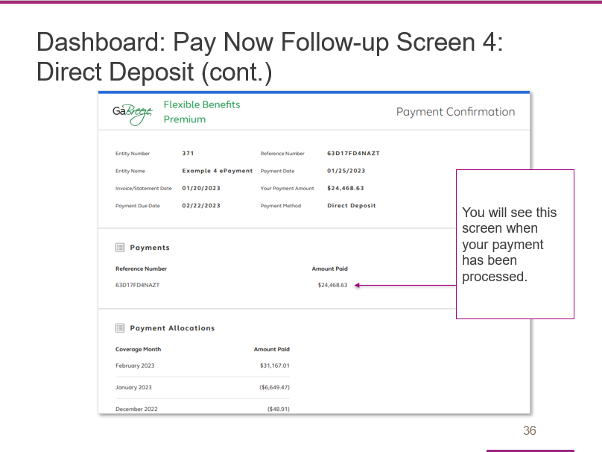

This screen shows what you will see when your payment has processed.

Slide 37

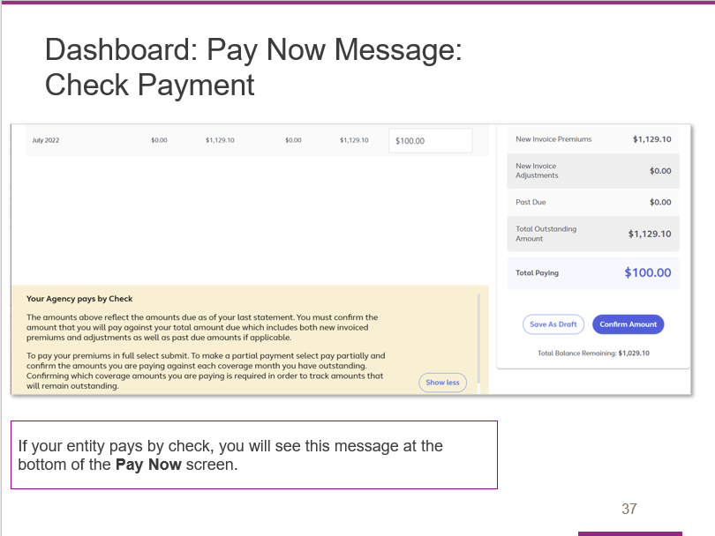

If your entity pays by check, you will see this message at the bottom of your Pay Now screen.

Review this message before you select Confirm Amount.

Slide 38

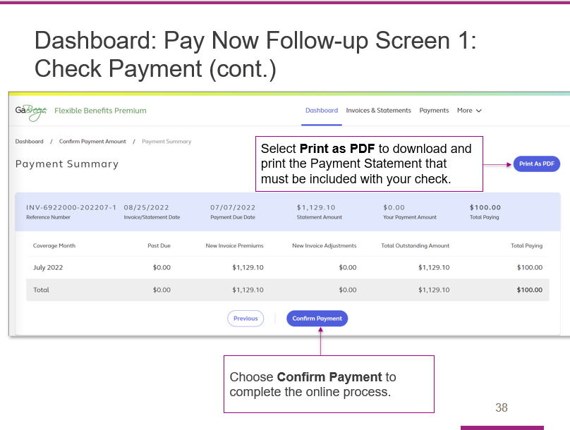

After you confirm your payment amount on the prior screen, you will see this Payment Summary screen. You need to complete two steps to process your payment:

First, select the Print as PDF button to download and print the payment statement that must be included with your check payment.
- The statement has instructions on where and by when to mail the check. It also includes prepopulated information that facilitates the processing of the check at the Alight/Citi lockbox.
- A manufactured number included on the statement is keyed along with the check.
Alight Solutions then uses this number to associate the check payment with the correct entity.
Second, after you have downloaded and printed the statement, select Confirm Payment to complete the online process.

Slide 39

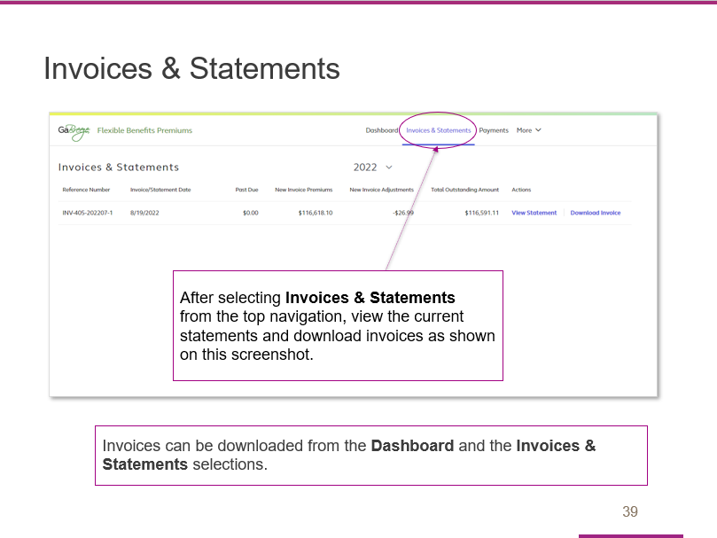

Now we’ll discuss invoices and statements.

The Invoices & Statements link at the top of the dashboard takes you to a page where you can view current statements and download invoices.

Your entity receives both an invoice and statement.

Slide 40

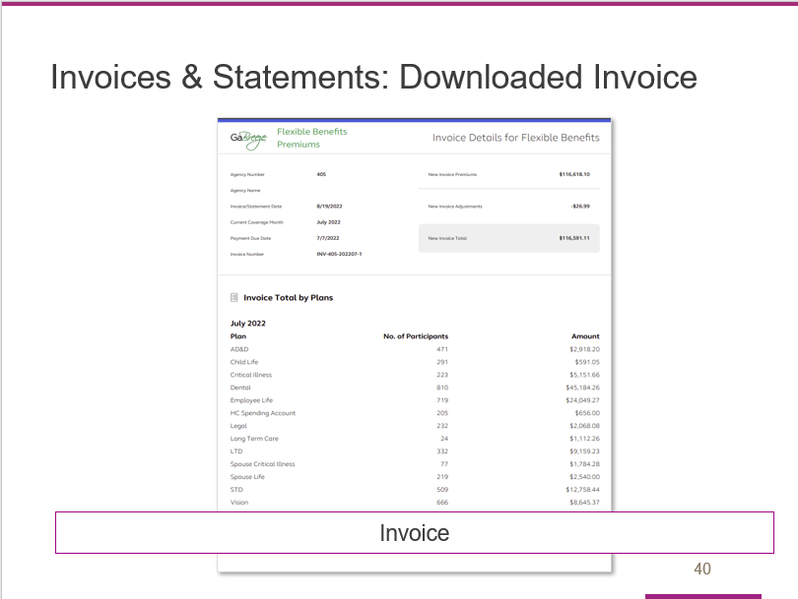

The invoice can be downloaded from the site as a PDF and shared within your entity for financial approval and routing.

Your invoice includes new premiums and new adjustments that have been calculated in the current billing cycle.

Slide 41

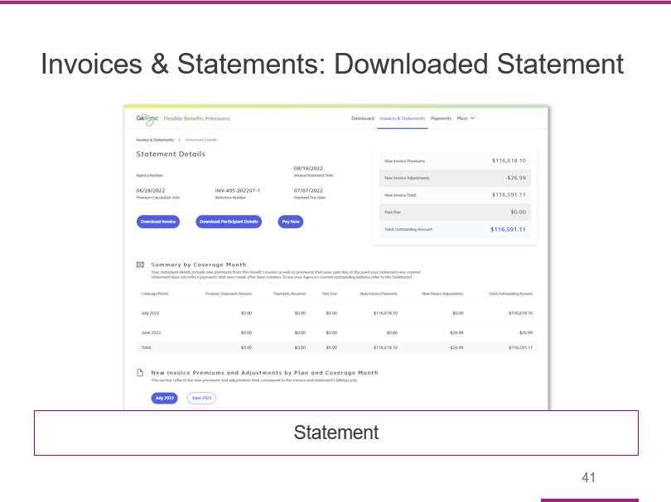

Your monthly statement can be viewed online and shows the same details of new premiums and new adjustments included in your invoice.

In addition, your statement shows payments received since your last invoice/statement.

It also shows any remaining past due balances if any previous invoices were not paid in full when the statement was created.

Slide 42

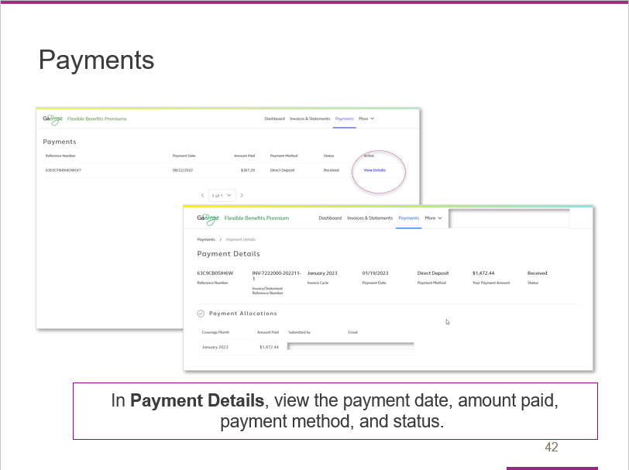

The next link in the top navigation takes you to the Payments page, where you can view the payment date, amount paid, payment method and status.

From the Payments page, you can select the View Details link to reach the Payment Details page.

Once you reach the Payment Details page, you can view the payment date, amount paid, payment method and status.

Slide 43

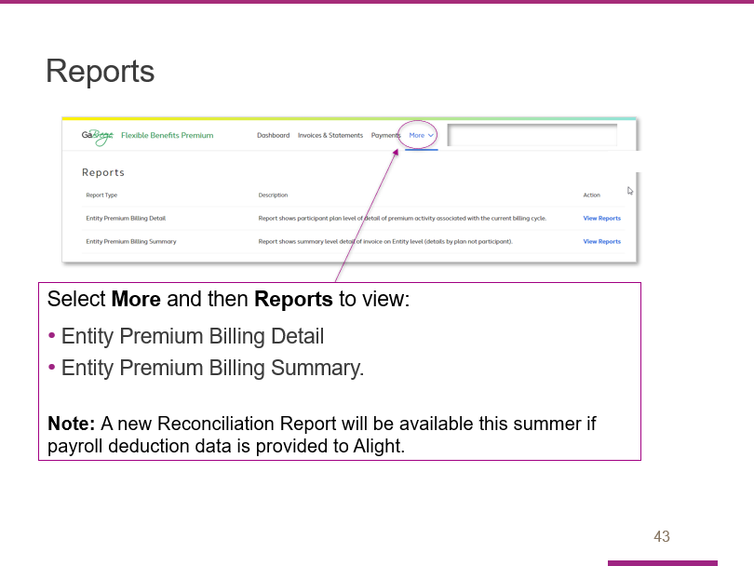

Select More and then Reports to view a page that lists all available reports, including:
- Entity premium billing detail
- Entity premium billing summary

You will see a short description of each report as well as a link to the actual report.

Slide 44

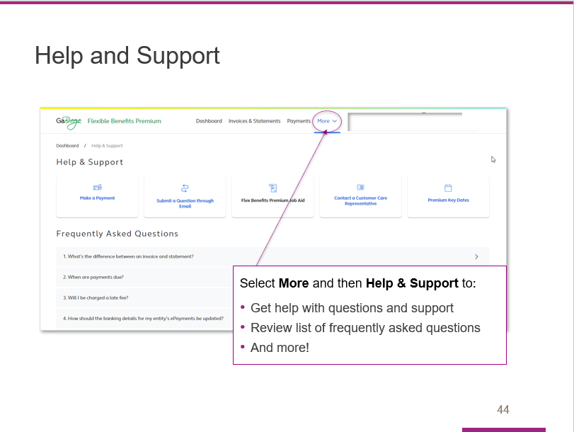

Select More and then Help & Support to:

- Get help with questions and support
- Review of list of frequently asked questions, or FAQs
- And more!

Slide 45

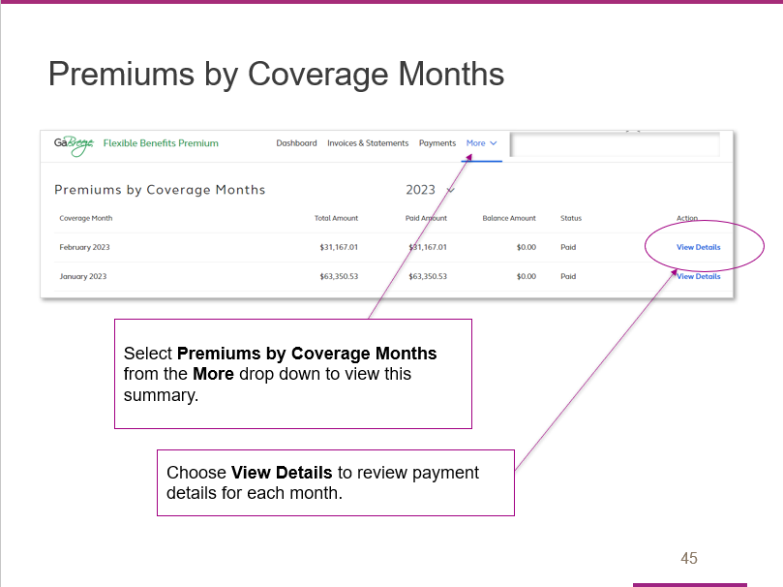

The More menu contains a link to the Premiums by Coverage Months summary page.

After you review the information on this screen, select View Details to proceed.

Slide 46

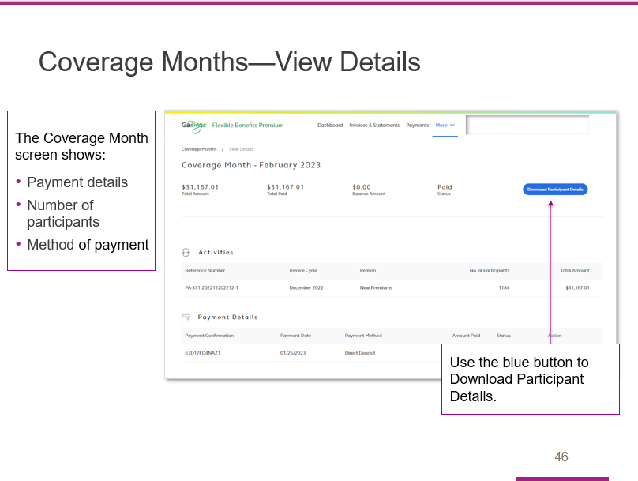

In addition to providing payment details, the View Details page also shows the number of participants and method of payment.

You can also download participant details from this page.

Slide 47

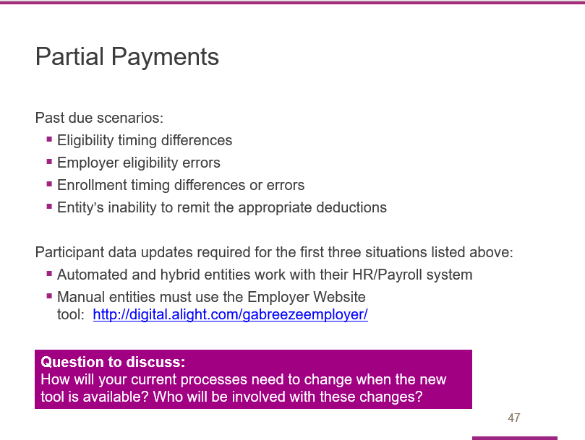

Entities are expected to pay the amounts invoiced. Those who do not pay as expected will be considered past due.

However, the financial payment tool will allow entities to pay amounts less than what's invoiced; however, if you pay less than the amount invoiced, the below scenarios will still be treated as delinquent/past due:
- Eligibility timing differences – eligibility changed after an invoices' premiums were calculated vs. when payments are submitted.
- Employer eligibility errors – eligibility updates that were not sent to Alight as expected.
- Enrollment timing differences or errors – enrollment processed after an 'invoices' premiums were calculated vs. when payments are submitted or participants who missed enrollments or enrolled in an unintended option.
- The entity’s inability to remit the appropriate deductions from payroll to cover employees' premiums.

For the first three situations, entities are expected to submit participant data updates.
- Automated and hybrid entities should work with their HR/Payroll teams to make any necessary updates.
- Manual entities must use the Employer Website tool to update participant details. This tool is available at http://digital.alight.com/gabreezeemployer/

Question to consider: How will your current processes need to change and who will be involved with the changes and what those changes will be. For example: Who will compare the payroll deduction reports to the benefit premium reports? Who will confirm the payments in the tool? Who will ensure the payment is confirmed in the tool prior to the payment being paid to Alight? When will the payroll and benefit reports be compared?
Slide 48

During this section of the training, participating entities were able to watch a live demo of the tool.

Slide 49

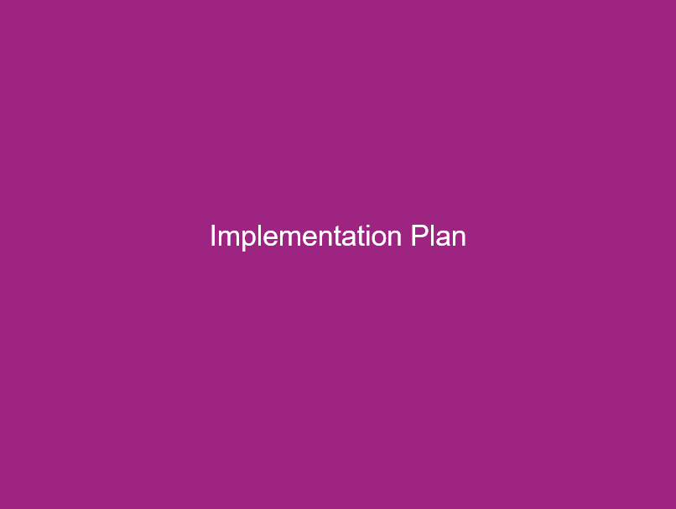

As we wrap up the prepared training program, we want to touch on the project timeline and highlight available resources and support.

Slide 50

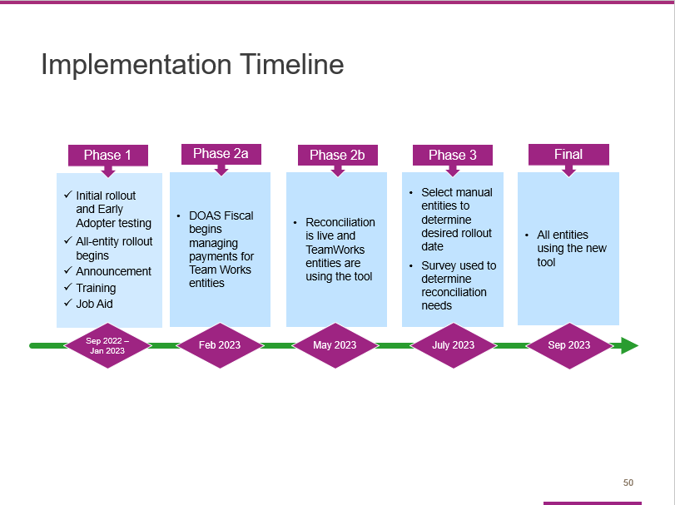

Here is an overview of the implementation timeline.

Slide 51

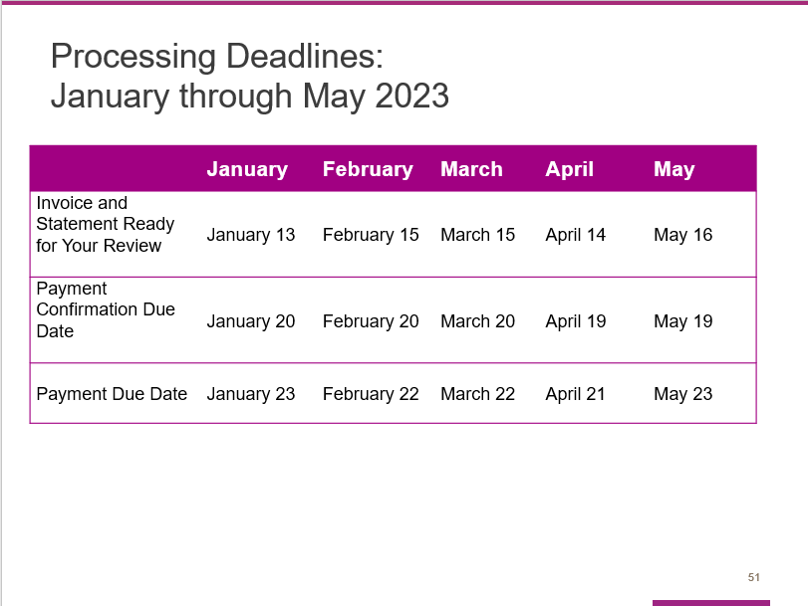

Here are the processing deadlines for the next few months.

Slide 52

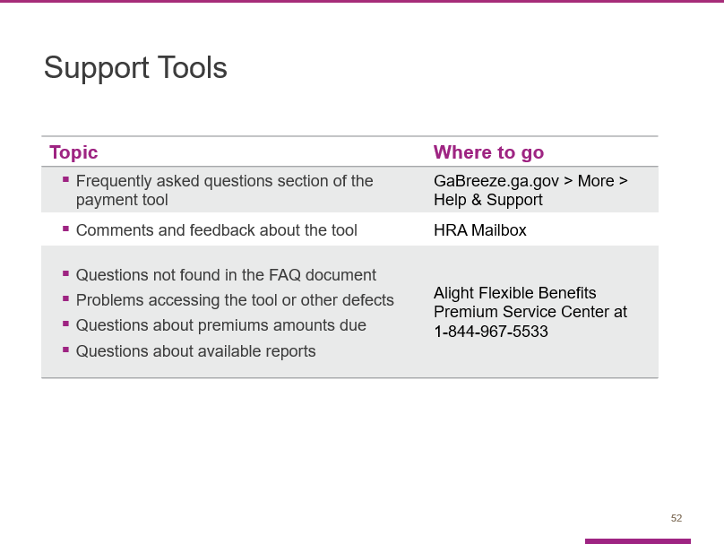

Use these resources if you need help, have questions or want to provide feedback.

Please note that the FAQs are embedded in the payment tool. There is not a separate document.

Slide 53

What questions or comments do you have after this training?

Slide 54

Slide 55

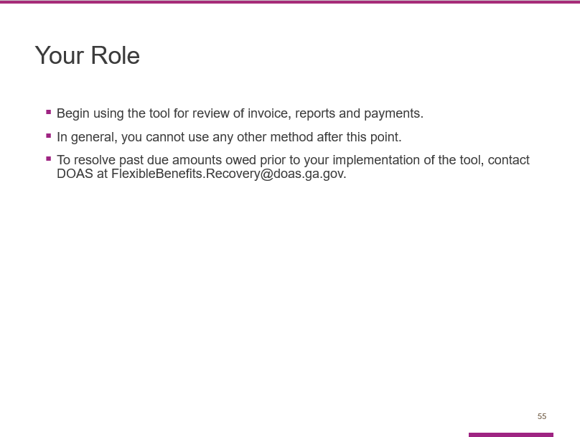

Your Entity is expected to start using this tool after today’s training.

In general, you cannot use any other payment methods after today.

To resolve past due amounts owed prior to your implementation of the tool, contact DOAS at FlexibleBenefits.Recovery@doas.ga.gov.

Slide 56

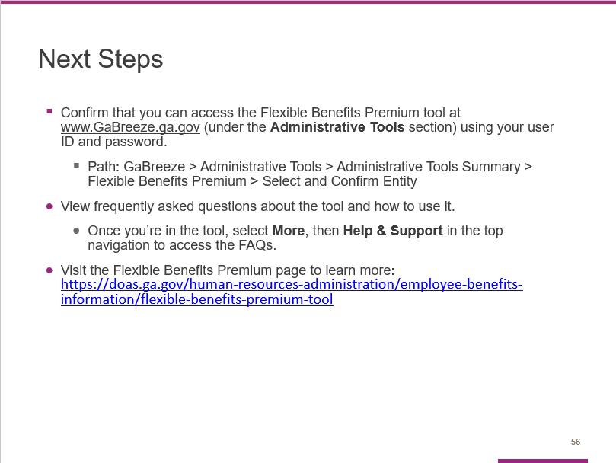

In terms of immediate steps, please take a few minutes to confirm that you can access the Flexible Benefits Premium tool at www.GaBreeze.ga.gov (under the Administrative Tools section).

If you experience technical difficulties, please call the number shown on this slide. If you have questions about the tool or this training, contact the Flexible Benefits team at HRA.flexbenefits@doas.ga.gov.

Slide 57

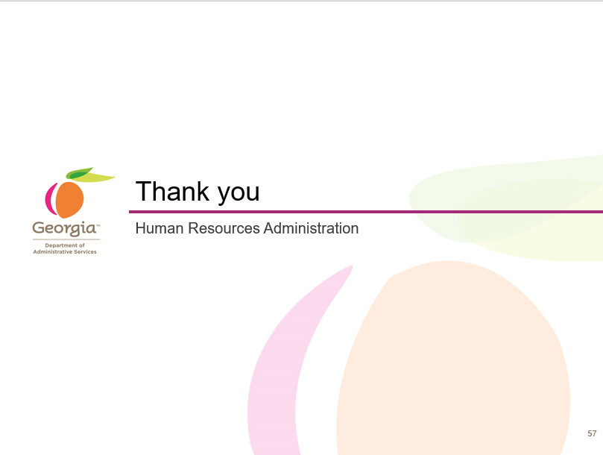

Wrap-up:

Thank you for participating in our training.

